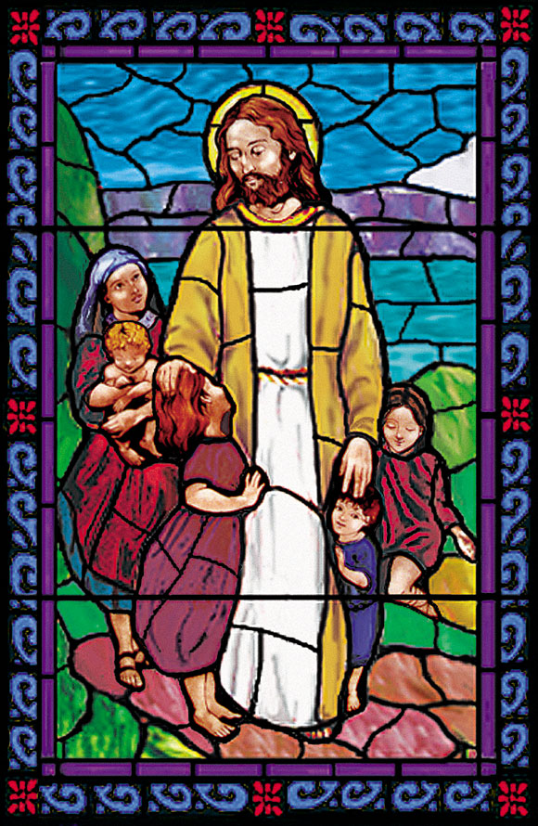
Christ Episcopal Church
105 Cottage Place, Ridgewood, NJ 07450
201. 652. 2350 www.christchurchridgewood.org

2018 - 2019
Youth Programs Registration Form

 | Sunday School |  | Jubilation Choir (K - 12th grades)
 | Acolyte |  | Youth Sundays
 | Chimes |  | Readings
 | Nursery (infants – age 3) |  | Instrumentalist
 | Christmas Pageant (all ages) |  | Mission Trip (8th grade – college)
 | African Drumming (2nd -12th grades) |  | Journey to Adulthood (9th – 12th grades)
 | Youth Group |  | Assist Sunday School

Youth’s Name: __________________________________________________________

Today’s Date: _______________ Youth’s Date of Birth: ______________________

Age (as of September 2018): _____ Grade (2018-2019 school year): _____

Parent (s) Names: ___________________________________________________

Home Address: ___________________________________________________________

E-mail address (s): ___________________________________________________

Phone contacts: ______________ ______________ _____________
Home Cell Cell

Notes (please list any allergies, disabilities, or other information that you feel we should know about your child to enhance their experience):
_____________________________________________________________________

_____________________________________________________________________

Parents – What would you like to do to support the work of Christ Episcopal Church’s Youth Ministries?
______________________________________________________________________

Parents – Do you consent to have your child’s picture (without ID) used on the Christ Church website, local newspapers, Social Media sites (Facebook, Instagram, Twitter, etc.) and bulletin boards?

Circle one: Yes No

